***“Heaven’s Light is Our Guide”***



**Department of Computer Science & Engineering**

**RAJSHAHI UNIVERSITY OF ENGINEERING & TECHNOLOG**

**Lab Report**

|  |
| --- |
| **Submitted By:**  **Name: Khandoker Sefayet Alam**  **Roll:2003121**  **Department: Computer Science & Engineering**  **Section-C**    **Course code: CSE 3102**  **Course name: Database Management System** |

|  |
| --- |
| **Submitted To:**  **Barshon Sen** |

TABLE Creation:

CREATE TABLE `movie_characters` (

  `Character _ID` int(11) NOT NULL,

  `Character_Name` varchar(100) NOT NULL,

  `Age` int(11) NOT NULL

)

INSERT INTO `movie_characters` (`Character _ID`, `Character_Name`, `Age`) VALUES

(1, 'Apu', 7),

(2, 'Durga', 10),

(3, 'Harihar', 42),

(4, 'Sarbajaya', 35),

(5, 'Ramesh', 28),

(6, 'Hemnalini', 25),

(7, 'Nalinaksha', 30),

(8, 'Kamala', 20),

(9, 'Shikha', 21),

(10, 'Apratim', 26),

(11, 'Feluda', 25),

(12, 'Maganlal Meghraj', 35),

(13, 'Jatayu', 45),

(14, 'Topshe', 18),

(15, 'Ruku', 6),

(16, 'Faruk', 22),

(17, 'Bithi', 19),

(18, 'Sathi', 24),

(19, 'Lalon', 0),

(20, 'Kaluah', 25),

(21, 'Siraj Saain', 45),

(22, 'Komli', 25),

(23, 'Subir Banerjee', 0),

(24, 'Ashima', 24),

(25, 'Rashmoni', 0),

(26, 'Somalata', 24),

(27, 'Chaitali', 18),

(28, 'Byomkesh Bakshi', 26),

(29, 'Ajit', 27),

(30, 'Malati', 16),

(31, 'Debkumar', 50),

(32, 'Doctor Anukul', 45),

(33, 'Prabhat', 27),

(34, 'Satyabati', 22),

(35, 'Anadi Babu', 55),

(36, 'PK', 0),

(37, 'Jaggu', 26),

(38, 'Sarfaraz', 29),

(39, 'Tapasvi Maharaj', 50);

ALTER TABLE `movie_characters`

  ADD PRIMARY KEY (`Character _ID`);

CREATE TABLE `movie_character_relationship` (

  `Character_ID` int(11) NOT NULL,

  `Movie_ID` int(11) NOT NULL

)

INSERT INTO `movie_character_relationship` (`Character_ID`, `Movie_ID`) VALUES

(1, 1),

(2, 1),

(3, 1),

(4, 1),

(5, 2),

(6, 2),

(7, 2),

(8, 2),

(9, 3),

(10, 3),

(11, 4),

(12, 4),

(13, 4),

(14, 4),

(15, 4),

(16, 5),

(17, 5),

(18, 5),

(19, 6),

(20, 6),

(21, 6),

(22, 6),

(23, 7),

(24, 7),

(25, 8),

(26, 8),

(27, 8),

(28, 9),

(28, 10),

(29, 9),

(29, 10),

(30, 9),

(31, 9),

(32, 9),

(33, 10),

(34, 9),

(34, 10),

(35, 10),

(36, 11),

(37, 11),

(38, 11),

(39, 11);

ALTER TABLE `movie_character_relationship`

  ADD KEY `Movie_ID` (`Movie_ID`),

  ADD KEY `Character_ID` (`Character_ID`);

**Level # 1**

❖ Query 1.1: Find the name and age of all the movie-characters who are not

teenagers.

Code:

SELECT Character_Name,Age FROM movie_characters WHERE (Age>=20 OR Age<=12)

Table:

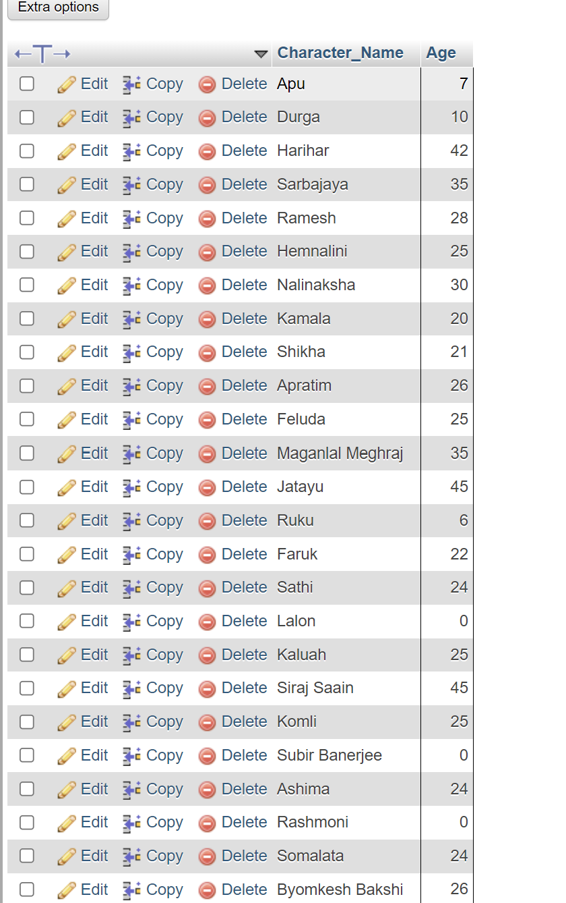

❖ Query 1.2: Find the movie ID of all the movies and the number of

movie-characters in each movie.

Code:

SELECT Movie_ID, COUNT(Character_ID) As number_of_movie_characters FROM movie_character_relationship GROUP BY Movie_ID

Table:

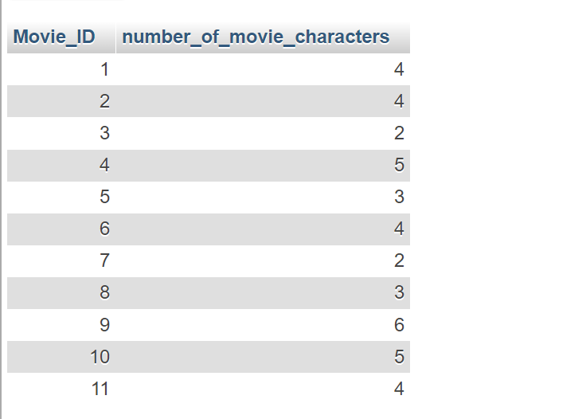

❖ Query 1.3: Find the movie name of all the movies and the number of

movie-characters in each movie.

Code:

SELECT movie.Movie_Name,COUNT(movie_character_relationship.Character_ID) As character_count FROM movie LEFT JOIN movie_character_relationship ON movie.Movie_ID=movie_character_relationship.Movie_ID GROUP BY movie.Movie_ID

Table:

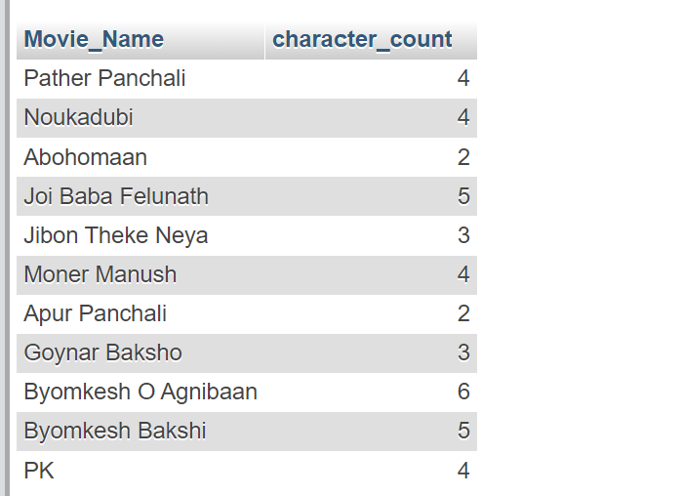

❖ Query 1.4: Find the name, year of release, IMDB rating and the name of the

director of all the movies that contain at most 12 characters (including

spaces) in their name.

Code:

SELECT movie.Movie_Name,movie.Year,movie.IMDB_Rating,director.Director_name FROM movie LEFT JOIN director ON movie.Director_ID=director.Person_Id WHERE LENGTH(movie.Movie_Name)<=12

Table:

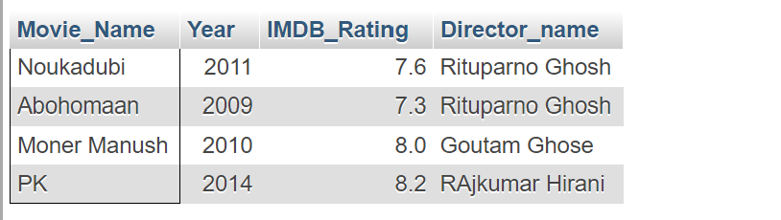

❖ Query 1.5: Display the name and the IMDb rating of the movie with the

highest IMDb rating in each genre.

Code:

SELECT movie.Movie_Name,movie.IMDB_Rating,movie.Genre FROM Movie JOIN (SELECT MAX(IMDB_Rating) AS MAXM,Genre FROM movie GROUP BY Genre) SUB ON movie.Genre=SUB.Genre WHERE movie.IMDB_Rating=SUB.MAXM

Table:

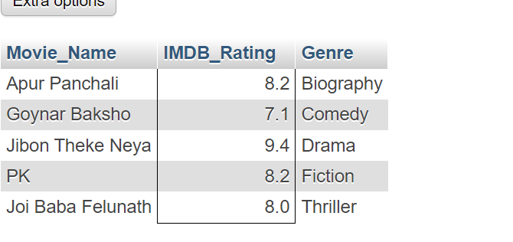

**Level # 2**

❖ Query 2.1: Find the name, year of release, IMDB rating of all the movies of

Byomkesh (N.B.**:** A movie of Byomkesh may not contain the term

‘Byomkesh’ in its name).

Code:

❖ Query 2.2: Find the name of all the movies and, the name & the age of the

youngest movie-character in each movie.

Code:

❖ Query 2.3: Find the name and age of all the characters from the movies of

Feluda (N.B.**:** A movie of Feluda may not contain the term ‘Feluda’ in its

name).

Code:

❖ Query 2.4: Find the name and age of all the characters from the movies

directed by Satyajit Ray.

➵ 2.4.1: Without Join (using Subqueries)

Code:

➵ 2.4.2: With Join

Code:

❖ Query 2.5: Find the movie genre with highest average IMDb rating.

Code:

SELECT Genre,Genre_avg FROM (SELECT Genre, AVG(IMDB_Rating) as Genre_avg FROM movie GROUP BY genre) AS SUB WHERE Genre_Avg=(SELECT MAX(Genre_avg) FROM (SELECT AVG(IMDB_Rating) as Genre_avg FROM movie GROUP BY genre) As sub2)

Table:

